INTERNSHIP REPORT
Main Report Guidelines:

Alignment of the documentation:

- Margins: Page Layout {Top: 1”, Bottom: 1”, Left: 1.5”, Right: 1”}
- Header:
- Footer: Page Number Compulsory

Formatting Instruction:
- Font Style: Times New Roman
- Main Heading Size: 16 (Bold)
- Sub Headings Size: 14 (Bold)
- Content/Text Size: 12
- Line Spacing: 1.5
- Text Alignment: Justified
- Justification: Even Distribution

- Figures and tables should be middle-aligned.
- The quality of the paper should be extended bond paper.
- Color Print is preferable for better clarity and visualization, when included with images.

Project Report Writing Guidelines
Abstract
- The abstract should contain 200–300 words.
- It should briefly describe the objective, methodology, results, and conclusion of the project.
Formatting Instructions:
- Font Style: Times New Roman
- Main Heading Size: 16 (Bold)
- Sub Headings Size: 14 (Bold)
- Content/Text Size: 12
- Line Spacing: 1.5
- Text Alignment: Justified

Example:
ABSTRACT (Font: Times New Roman, Size 16, Bold)

Tables
- Tables should be numbered and labeled with respect to the chapter.
Examples:
- Table 1.1 – First table in Chapter 1
- Table 1.2 – Second table in Chapter 1
- Table 2.1 – First table in Chapter 2
- The table title should appear above the table
Example:
Table 1.2: Student Data Records

Figures
- All diagrams, graphs, and screenshots should be labeled as Figures.
- Figures should also follow chapter-wise numbering.
Examples:
- Figure 1.1 – First figure in Chapter 1
- Figure 1.2 – Second figure in Chapter 1
- The caption should appear below the figure.

ExampleS:
- Figure 1.2: System Architecture

Abbreviations:
- Abbreviations must be defined.
- It should be in the tabular form
URL | Uniform Resource Locator
HTML | HyperText Markup Language
CPU | Central Processing Unit
AI | Artificial Intelligence
DBMS | Database Management System
Example:

1.Introduction
- The Introduction should contain a maximum of 500 words.
- It should clearly explain:
  - Background of the project
  - Problem statement
  - Objectives of the system
  - Importance of the project
  - Scope of the system
- Students must explain why the project is needed and what problem it solves.
Example Structure
- Background of the problem
- Need for the system
- Objectives of the project
- Scope and limitations

2. Literature Survey
Students should review existing studies, systems, or research related to the project topic.

Types of Research

1. Primary Research
- Information collected directly from the source.
- Methods include:
  - Surveys
  - Interviews
  - Questionnaires
  - Observations
Example:
If the project is Library Management System, students may conduct a survey among librarians and students to understand problems in the current system.

2. Secondary Research
- Information collected from existing sources such as:
  - Books
  - Research papers
  - Journals
  - Websites
Example:
Studying different existing library management systems from research papers or websites.

3. Specifications Overview
This section explains the basic specifications of the system.
It should include:
- Hardware requirements
- Software requirements
- Tools and technologies used
Example:
Hardware Requirements
- Processor: Intel i3 or above
- RAM: 4 GB or above
- Hard Disk: 500 GB
Software Requirements
- Operating System: Windows 10
- Programming Language: Python / Java
- Database: MySQL

4. Requirement Analysis
This section explains what the system needs to do.
Types of requirements:

Functional Requirements
- Login system

Example:
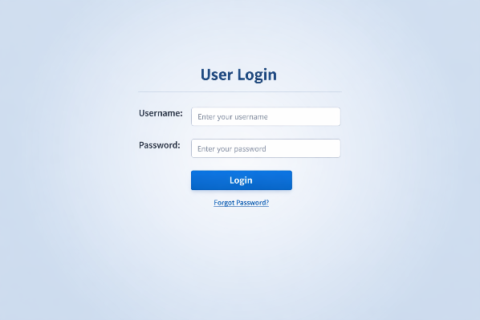
- Data entry
- Report generation
- User management

Non-Functional Requirements
- Security
- Performance
- Reliability
- User-friendly interface

5. System Design
This section explains how the system is designed.
It may include:
- System Architecture
Example:
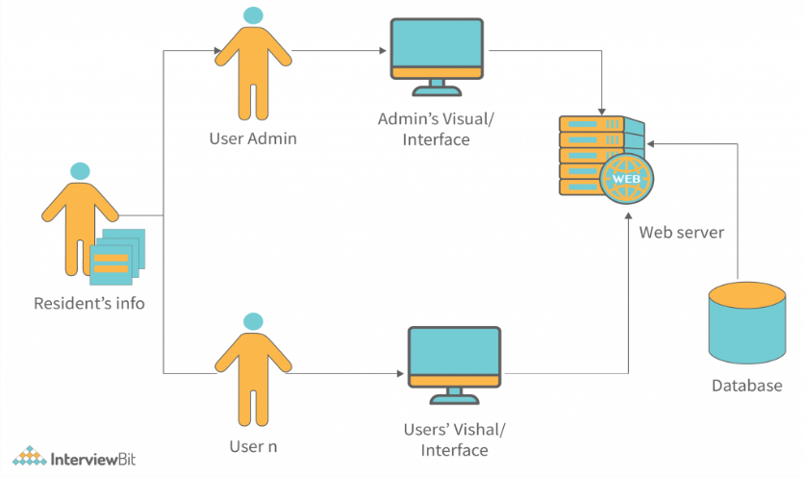
- Flowcharts
Example:
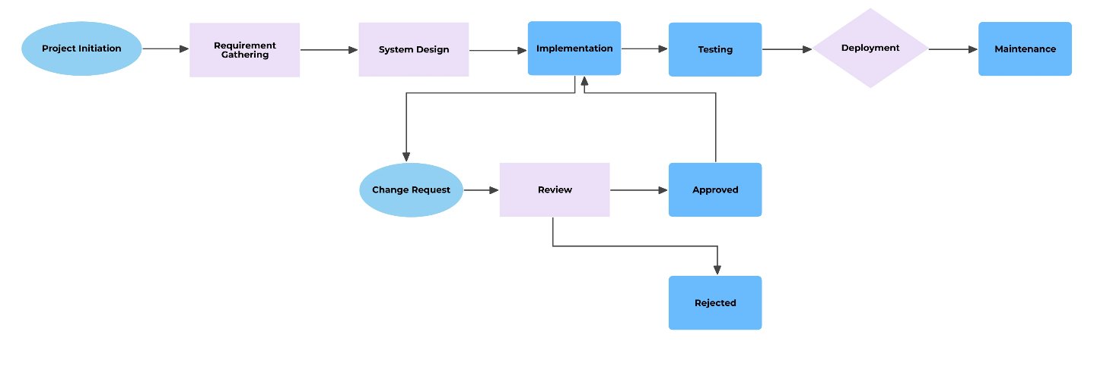
- Data Flow Diagrams (DFD)
Example:
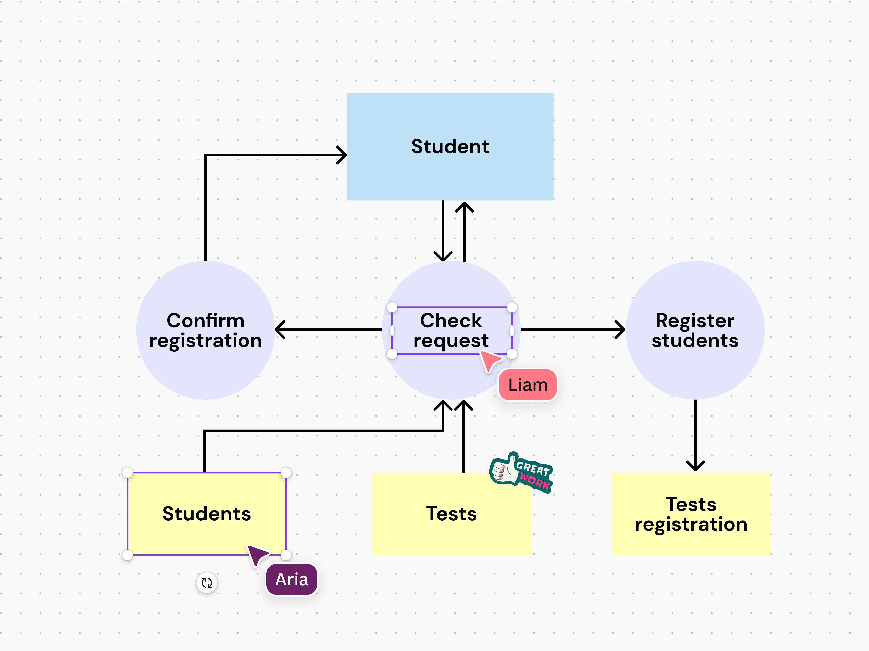
- Database Design
Example:
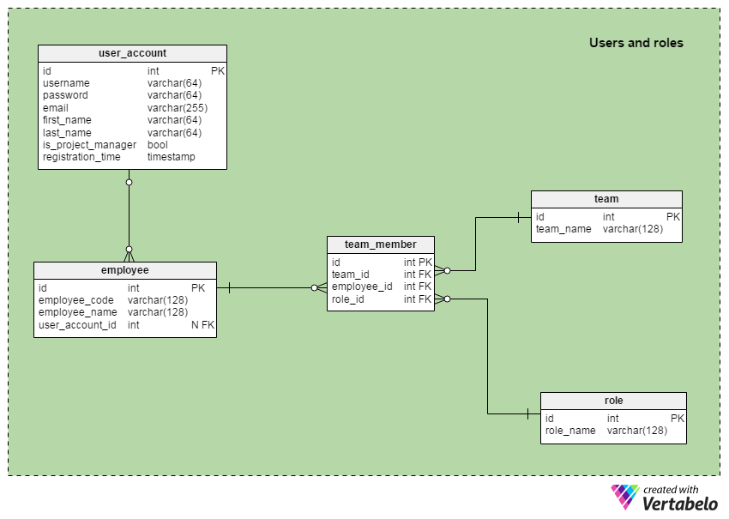
- UML Design
Example:
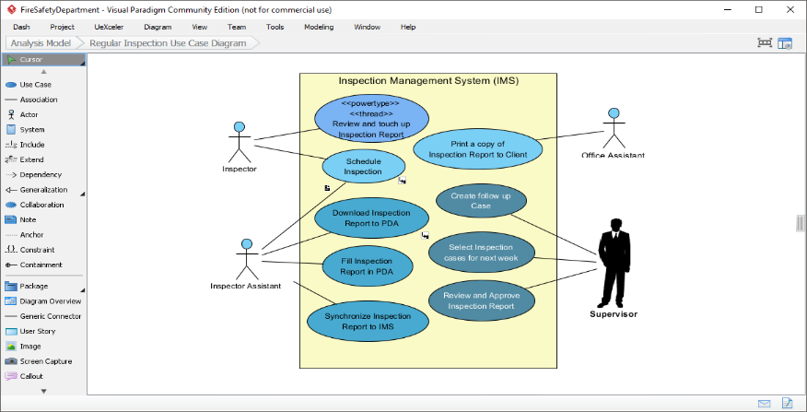
- Class diagrams
Example:
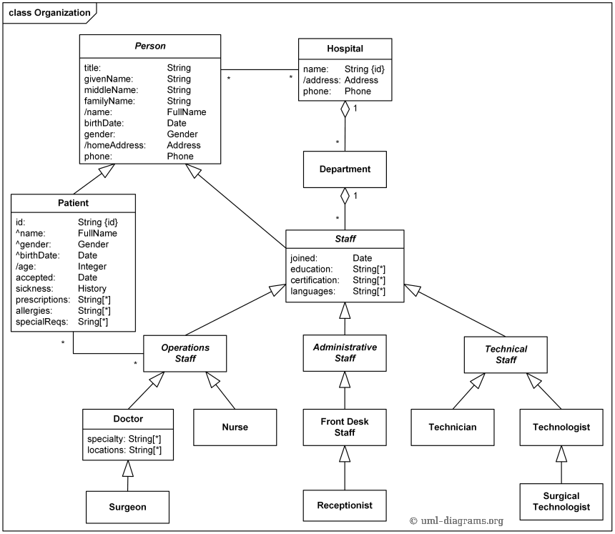
- Use case diagrams
Example:
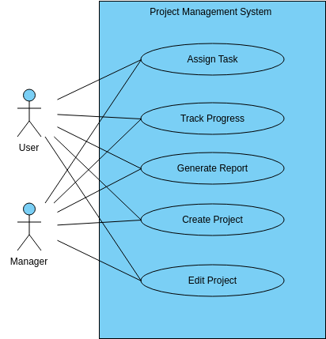
- Sequence diagrams
Example:
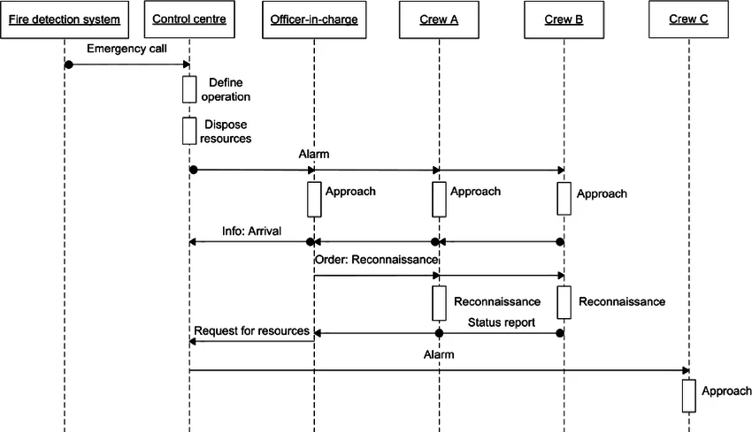
- Activity diagrams
Example:
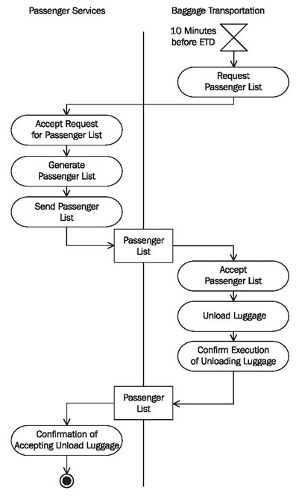
Example:
A DFD diagram showing how data moves between user, database, and system modules
\\ Based on your project, include diagrams

6. Implementation
This section explains how the system is developed.
Students must include:

1. Source Code
- Include important parts of the code
- Example code for:
  - Login module
  - Database connection
  - Main functionality

Example:
import mysql.connector

conn = mysql.connector.connect(
host="localhost",
user="root",
password="",
database="project_db"
)

print("Database Connected Successfully")
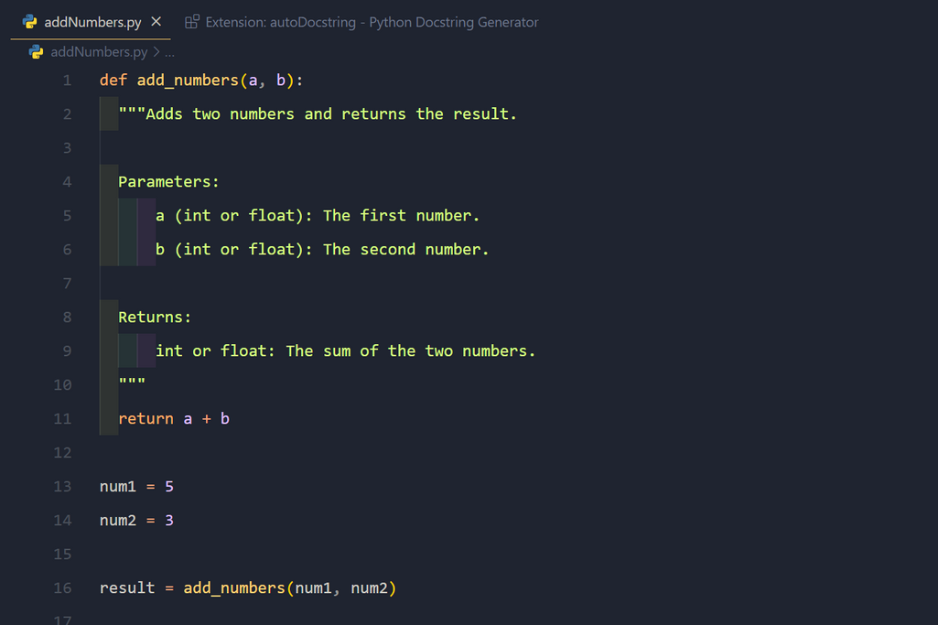

Students must include:
- Output screenshot
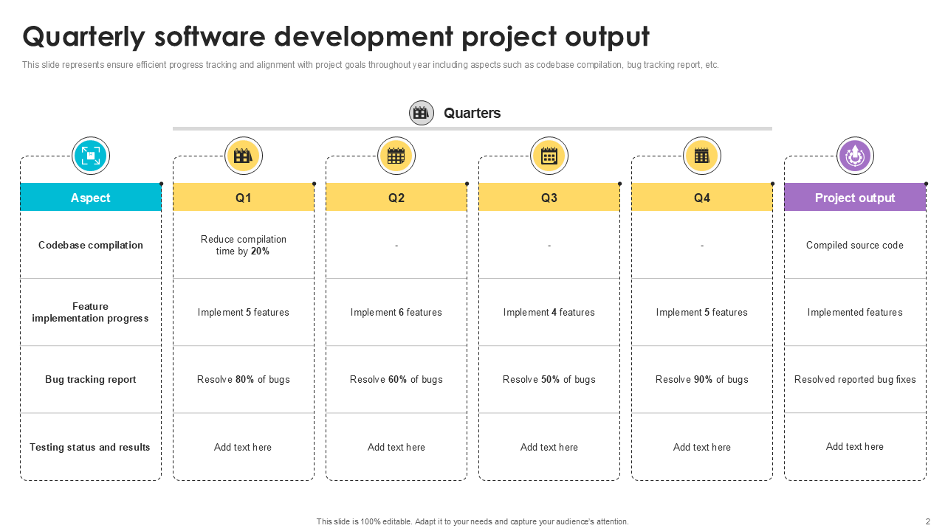

7.Test Case
Testing should include different types.

1. Unit Testing
Testing individual modules.
Example:
Test Case ID | Module |  | Input | Expected Output | Result
TC01 | Login |  | Correct Username & Password | Login Successful | Pass
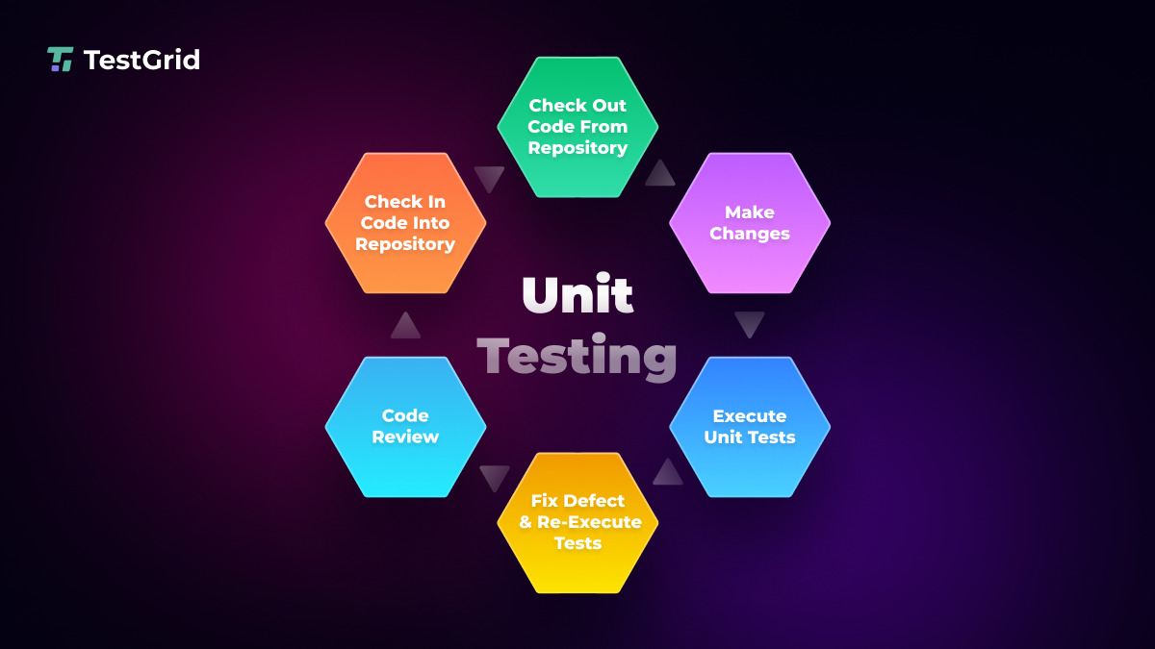

2. Integration Testing
Testing interaction between modules.
Example:
Test Case ID | Modules | Input | Expected Result
TC02 | Login + Database | Valid credentials | User logged in

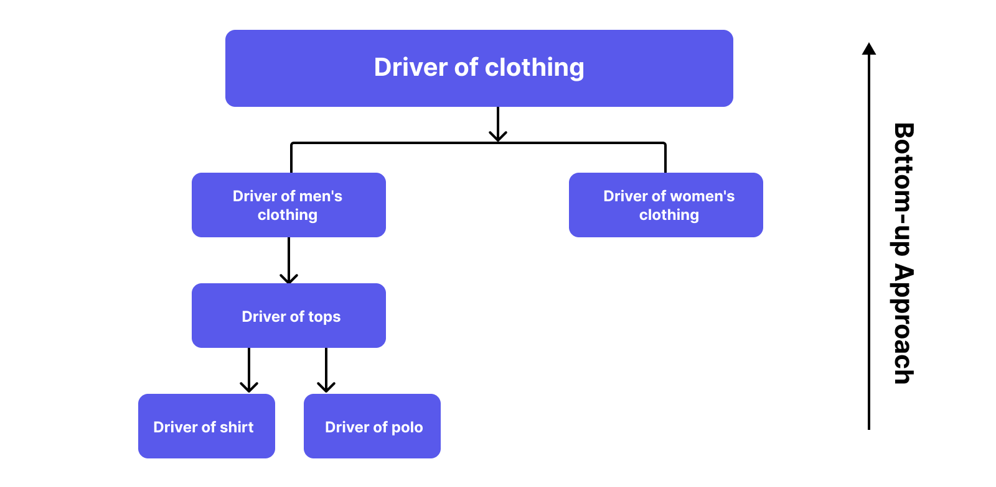

3. System Testing
Testing the entire system functionality.
Example:
Test Case | Description | Expected Result
TC03 | Complete booking process | Booking successful
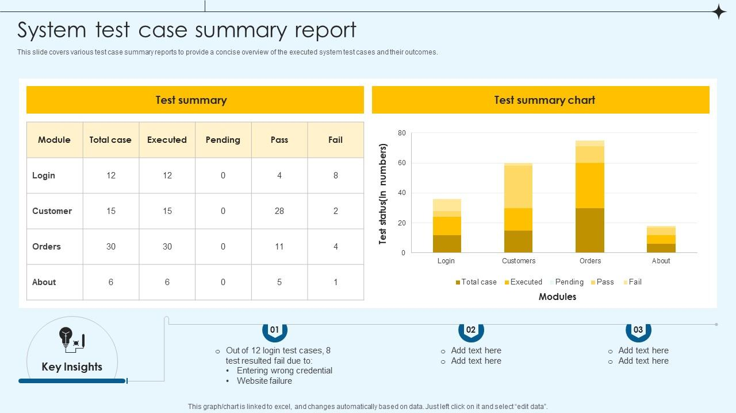

8. Feature Enhancement
- New features you can add in future
- Improvements to existing system
- Better performance ideas
- Security improvements
- User experience (UI/UX) improvements
- Any advanced technologies (mobile app, AI, etc.)
Example:
The system can be improved by adding a user-friendly interface, advanced search options, real-time notifications, secure online payment integration, and better data security. It can also be enhanced with mobile compatibility, report generation, and improved performance for faster operations.
9. Conclusion
- What the project does (brief summary)
- Whether objectives are achieved
- Benefits of the system (time saving, accuracy, etc.)
- Overall result of the project
- Future scope (possible improvements)
Example:
The project is successfully implemented to manage booking, enquiry, payment, and trip details efficiently. It reduces manual work and improves accuracy. The system is reliable and user-friendly, with scope for future enhancements like mobile access and advanced features.
10.Biblography

Students must include minimum 15 references.
References can include:
- Books
- Research papers
- Journals
- Websites

Example Book Reference
Forsyth, D. A., & Ponce, J. (2009).Computer Vision: A Modern Approach.PHI Learning.

Example Website Reference
OpenCV Documentation https://opencv.org

Example Journals and Research Papers
- Nature, Science, Proceedings of the National Academy of Sciences (PNAS), Nature Communications.
- Attention Is All You Need" (Vaswani et al., 2017 - NIPS). This paper introduced the Transformer architecture, forming the basis for LLMs like GPT.

